**UI Design**

AIUB Lifeline- Homepage

AIUB Lifeline- Login Page

AIUB Lifeline- Registration Page

AIUB Lifeline- Password Reset

AIUB Lifeline- Student Dashboard

Chatbox  
  
  
AIUB Lifeline- Student Edit Profile

AIUB Lifeline- Faculty Dashboard  
  
  
  
  
  
  
  
  
  
  
  
  
  
  
  
  
  
  
  
  
AIUB Lifeline- Faculty Edit Profile  
  
  
  
  
  
  
  
  
  
  
  
  
  
  
  
  
  
  
  
AIUB Lifeline- Admin Dashboard

AIUB Lifeline- Admin Edit Profile

AIUB Lifeline- Lost & Found Area  
  
AIUB Lifeline- Post about a lost item

AIUB Lifeline- Lecture Material & Notes Area  
AIUB Lifeline- Post a Note/Material

AIUB Lifeline- Open Notes/Material

AIUB Lifeline- Faculty TFS Search

AIUB Lifeline- Q&A Area

AIUB Lifeline- Post a Question

AIUB Lifeline- View Question

AIUB Lifeline- Blogs  
  
  
  
  
AIUB Lifeline- Blogs Detailed Page

AIUB Lifeline- About Page  
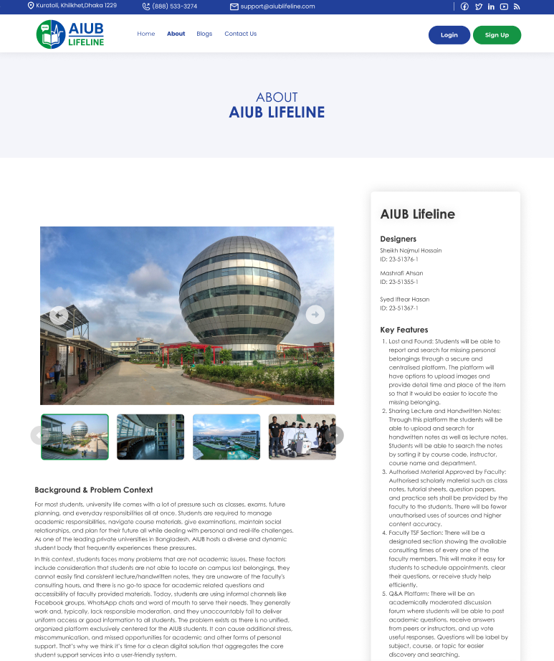

AIUB Lifeline- Support Page

AIUB Lifeline- Terms and Conditions

AIUB Lifeline- Privacy Policy  
